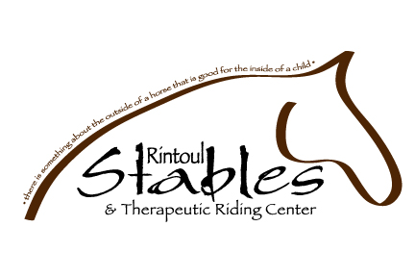

SAFETY ISSUE ACKNOWLEDGEMENT AND RELEASE
Page 1 of 2

I, ______________________________________________ am the Parent/Guardian of the Infant
(Print Parent/Guardian’s name)

Participant, _______________________________________________and am executing this waiver
(Print Participant’s name)
on behalf of the Infant Participant in my capacity as Parent/Guardian and with the intent that this waiver be binding on myself and the Infant Participant for all legal purposes. I, the undersigned have read and understand and freely and voluntarily sign this Acknowledgement and Release with Rintoul Stables & Therapeutic Riding Center and understanding this is a waiver of any and all liability.

I recognize that there are certain risks, dangers and perils connected with the use of horses in general, whether leading, feeding or mounting and especially riding as well as in a lesson, camp, equine assisted learning, therapeutic riding or clinic environment, including, but not limited to, any interactions with horses. Under these conditions, I realize Rintoul Stables & Therapeutic Riding Center’s efforts to thoroughly inform and continually maintain safety for all concerned. I will faithfully adhere to all safety instructions and recommendations provided by Rintoul Stables & Therapeutic Riding Center, whether oral or written while on Rintoul Stables & Therapeutic Riding Center’s premises.

I, the undersigned parent/guardian, freely accept and fully assume all responsibilities for all “Risks” and possibilities of any and all claims, actions, costs, damages and expenses with respect to personal injury, death, property damage or loss resulting from the Infant Participant’s participation at Rintoul Stables & Therapeutic Riding Center and hereby release and forever discharge Rintoul Stables & Therapeutic

SAFETY ISSUE ACKNOWLEDGEMENT AND RELEASE
Continued Page 2 of 2

Riding Center and its respective employees and volunteers and anyone else directly or indirectly connected with Rintoul Stables & Therapeutic Riding Center.

Rintoul Stables & Therapeutic Riding Center also has my permission to use necessary medical measures in the event of emergency. I fully understand and accept the inherent risk involved in the activities my child will be or has chosen.

I GIVE PERMISSION to Rintoul Stables & Therapeutic Riding Center to take and use photographs at their discretion, inasmuch, as the reproductions are in good taste and respectfully displayed.

_____________________________________ _____________________
Parent/Guardian Signature Date

_____________________________________ _____________________
Rintoul Stables & Therapeutic Riding Center Date

