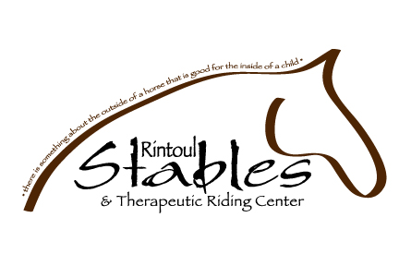

RIDER INFORMATION

Rider: _________________________________________________ Birthdate: _______________

Parent/Guardian:________________________________________________________________

Address: ______________________________________________________________________

Home: ___________________ Cell: ______________________ Work: _____________________

Email: ___________________________________ Riding Experience: ______________________

Family Doctor: ___________________________________ Phone: ________________________

SK Health#: _________________________ Allergies/Medication: ________________________

CAMP DATES/TIMES:

(Please check which camp(s) you are registering for)

- July 18-22 (9-3pm) = Beginner = $325.00 + gst ($65.00 deposit required)
- July 25-29 (9-3pm) = Intermediate =$325.00 + gst ($65.00 deposit required)
- August 8-12 (9-3pm) = Beginner =$325.00 + gst ($65.00 deposit required)
- August 15-19 (9-3pm) = Intermediate =$325.00 + gst ($65.00 deposit required)

- Bring your own horse ($25.00 board for the week)

Limited spots available. Rider spots are on a first come basis. Please make all cheques payable to Rintoul Stables & Therapeutic Riding Center. Deposits are non-refundable.

