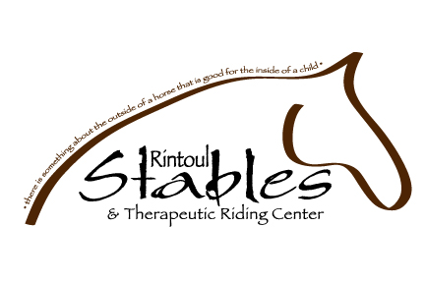

SAFETY ISSUE ACKNOWLEDGEMENT AND RELEASE

I, _____________________________________, the undersigned have read and understand and freely and voluntarily sign this Acknowledgement and Commitment Disclaimer with Rintoul Stables & Therapeutic Riding Center and understanding this is a waiver of any and all liability. I confirm that I have reached 18 years of age prior to signing this Acknowledgement and Commitment Disclaimer.

I recognize that there are certain risks, dangers and perils connected with the use of horses in general, whether leading, feeding or mounting and especially riding as well as in a lesson, camp, equine assisted learning, therapeutic riding or clinic environment, including, but not limited to, any interactions with other horses. Under these conditions, I realize Rintoul Stables & Therapeutic Riding Center’s efforts to thoroughly inform and continually maintain safety for all concerned. I will faithfully adhere to all safety instructions and recommendations provided by Rintoul Stables & Therapeutic Riding Center, whether oral or written while on Rintoul Stables & Therapeutic Riding Center’s premises.

I, the undersigned hereby release and forever discharge Rintoul Stables & Therapeutic Riding Center and its respective employees and volunteers and anyone else directly or indirectly connected with Rintoul Stables & Therapeutic Riding Center from and against all claims, actions, costs, damages and expenses with respect to damage and/or bodily injury as a result of my participation at Rintoul Stables & Therapeutic Riding Center. Rintoul Stables & Therapeutic Riding Center also has my permission to use necessary medical measures in the event of emergency. I fully understand and accept the inherent risks involved in the activities that I have chosen.

I GIVE PERMISSION to Rintoul Stables & Therapeutic Riding Center to take and use photographs at their discretion, inasmuch, as the reproductions are in good taste and respectfully displayed.

_____________________________________ _____________________
Participant Signature (18 yrs + older) Date

_____________________________________ _____________________
Rintoul Stables & Therapeutic Riding Center Date

